*I WILL USE WRITECHECK TO CHECK IF YOUR ARTICLE HAS ANY SIMILARITY WITH THE ARTICLES FROM WEB, IF THERE IS MORE THAN 1O% SIMILARITY, THE ANSWER WILL BE DENIED. So please don't waste your and my time if you just want to copy the source from any books or web to the paper you will give me. Please do summary and your own original work.

Art History: Renaissance to Modern Art
1st section: For the 6 power point images starting with the first one, write the significance using complete sentences—don’t describe the image. (Please read the information in Power Point 1st then do summary-the artist, name, and date of the art work is in the note part under the pages of power point)
1.

2.

3.

4.

5.

6.

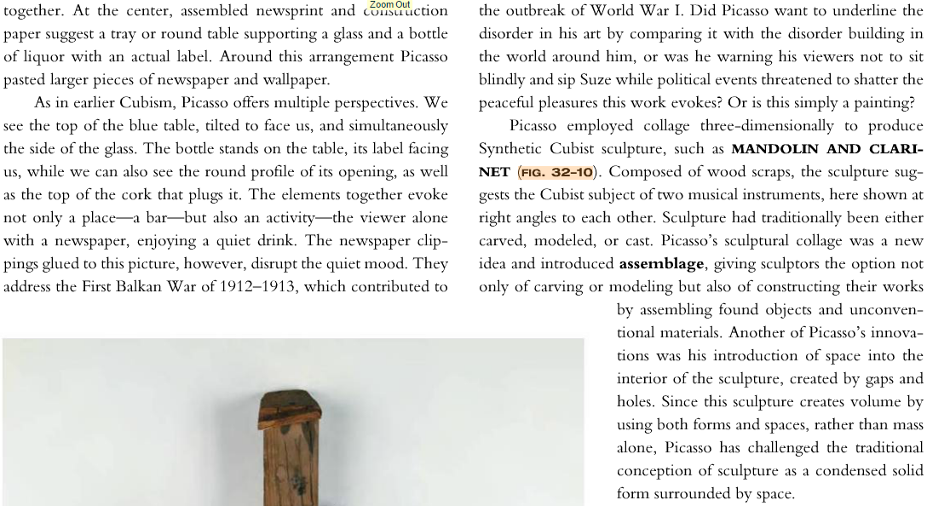
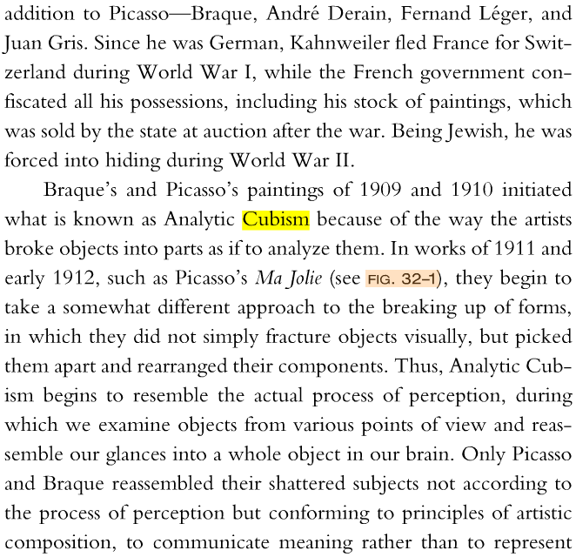
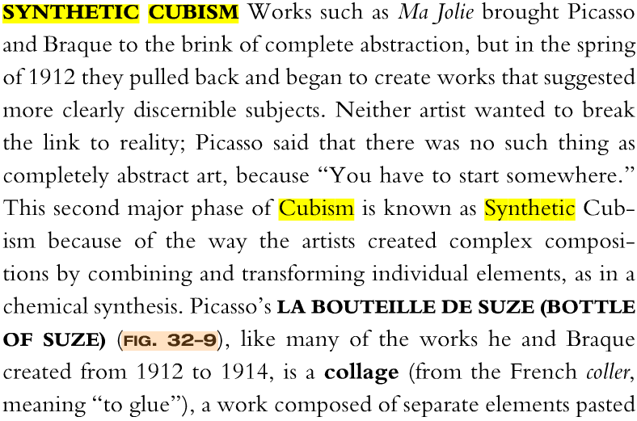
2nd Section: Long Answer-Read the text message first, then answer the question.
List 3 accurate characteristics of Synthetic Cubism.
1.
2.
3.

2. List 3 sources of inspiration used by the Surrealists.
1. Max Ernst, The Horde, 1927

2. Salvador Dali, Birth of Liquid Desires, 1921-1932

3. Joan Miro, Composition, 1933

3. List 3 discrepancies between the German Expressionist Groups the Bridge and The Blue Rider.
1.
2.
3.
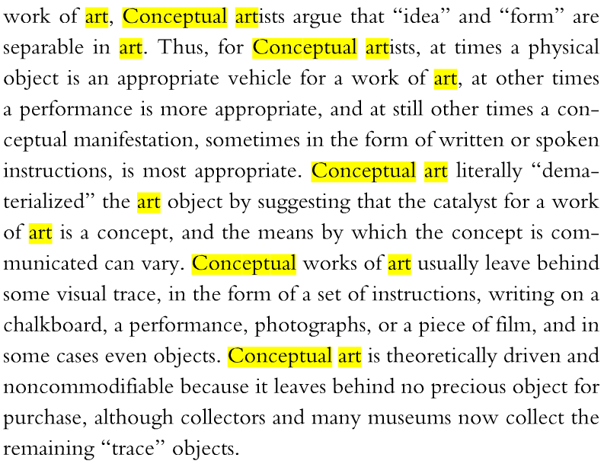
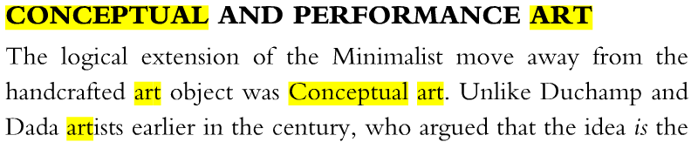
4. What is the most important element in Conceptual art?

